Name: ______________________________

Instructor’s Name: _____________________

Class/Period: _________________________

Date: _______________________________

**Unit 1: Literature Analysis**

Instructions: Use one of the short stories we read throughout the unit to write a literature analysis essay. Be sure to include an introduction (including a 3-4 sentence summary), two body paragraphs, and a conclusion.  
  
Prompt: Most short stories contain one or two themes that the author develops and attempts to convey to the audience. Using one of the short stories we read (“The Most Dangerous Game”, “The Scarlet Ibis”, or “The Cask of Amontillado”) write a four-paragraph essay analyzing (explaining) the story’s theme. Use direct quotes and examples from the text to support your analysis. Also, write a 3-4 sentence summary of the story in your introduction.

**THESIS STATEMENT –** *The central theme in the short story “______________________” by _____________________ is* _________________________________________________________.

**BRAINSTORM:**

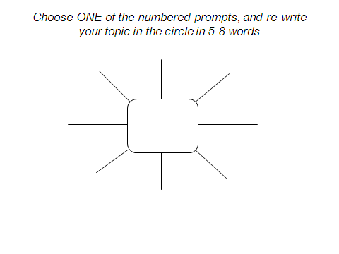

|  |  |
| --- | --- |
| Body Paragraph #1  Transitions  Claim: ______________________________________  Specific Example/Evidence 1:  ____________________________________________  ____________________________________________  ____________________________________________  ____________________________________________  Direct quote that supports specific example:  ____________________________________________  ____________________________________________  ____________________________________________  ____________________________________________  Explain & tie back to thesis:  ____________________________________________  ____________________________________________  ____________________________________________  ____________________________________________  ____________________________________________  TRANSITION: __________________________________  Specific Example/Evidence 2:  ____________________________________________  ____________________________________________  ____________________________________________  ____________________________________________  Direct quote that supports specific example:  ____________________________________________  ____________________________________________  ____________________________________________  ____________________________________________  Explain & tie back to thesis:  ____________________________________________  ____________________________________________  ____________________________________________  ____________________________________________  ____________________________________________ | Body Paragraph #2  Claim: _______________________________________  Specific Example/Evidence 1:  ____________________________________________  ____________________________________________  ____________________________________________  ____________________________________________  Direct quote that supports specific example:  ____________________________________________  ____________________________________________  ____________________________________________  ____________________________________________  Explain & tie back to thesis:  ____________________________________________  ____________________________________________  ____________________________________________  ____________________________________________  ____________________________________________  TRANSITION: __________________________________  Specific Example/Evidence 2:  ____________________________________________  ____________________________________________  ____________________________________________  ____________________________________________  Direct quote that supports specific example:  ____________________________________________  ____________________________________________  ____________________________________________  ____________________________________________  Explain & tie back to thesis:  ____________________________________________  ____________________________________________  ____________________________________________  ____________________________________________  ____________________________________________ |

**PARAGRAPH 1 – INTRODUCTION**

Brief summary of the short story (include title & author):

Thesis statement:

A general statement about the overall topic (hook):

**Paragraph 2:**

Body Paragraph 1

**Paragraph 3:**

Body Paragraph 2

**Conclusion:**

Recap the main evidence you discussed, and restate the theme of the piece.